**Software Engineering Tools Lab**

**Assignment No.8**

**Batch – T8**

# Q 1. What are the prerequisites for installing the TestLink tool.

Since TestLink is a web-application it follows the concept of client/server. It means that TestLink can be installed centrally on a server and users can interact with it through web browsers using a website from any computer.

* **Web Server** − TestLink supports Apache 2.2.2.1. However, it can work with any latest web server software. TestLink only uses .php file. Configure the web server with .php extension only.
* **PHP** − The web server should support PHP. It can be installed as CGI or any other integration technology. It is recommended to use 5.3.8 PHP version.
* **Mandatory PHP Extensions** − Extensions for RDBMS are mysqli, pgsql, oci8, sqlsrv. Mbstring is required for Unicode – UTF-8 support.
* **Optional Extensions** − Curl, GD, Fileinfo
* **Database** − TestLink requires database to store its data. MySQL (5.5.16) is recommended.
* **FileZilla FTP Server** − FileZilla FTP Server 0.9.39 is required to install XAMPP as optional.

Q 2. Install TestLink tool on your machine (Provide screen shots for successful installation and login)

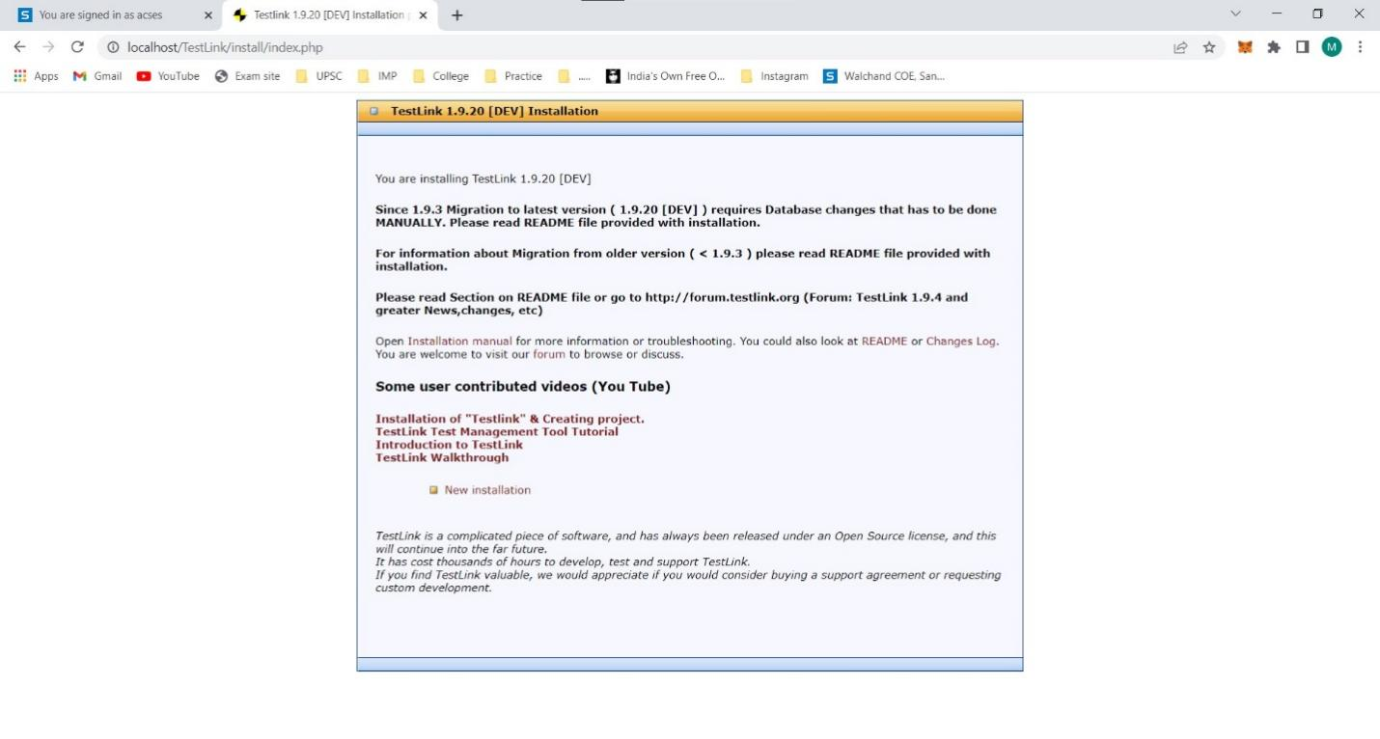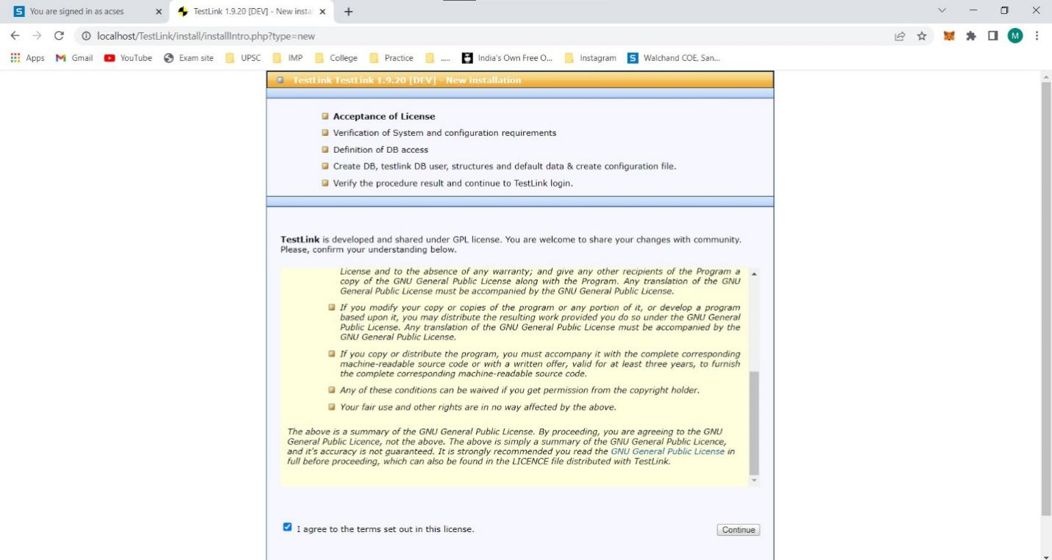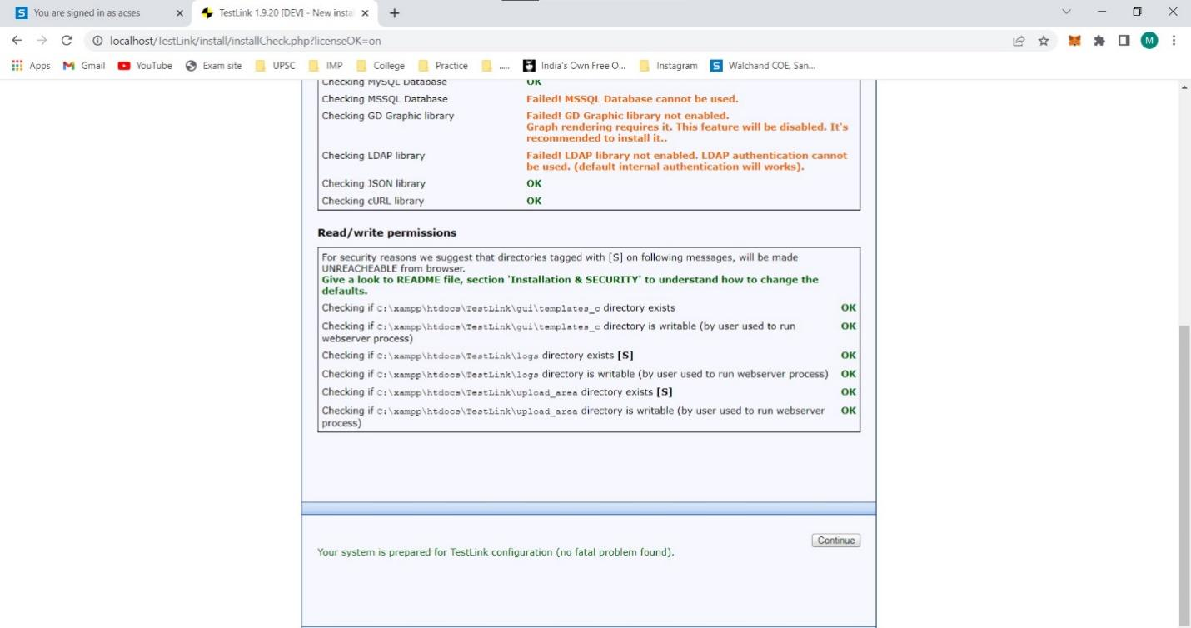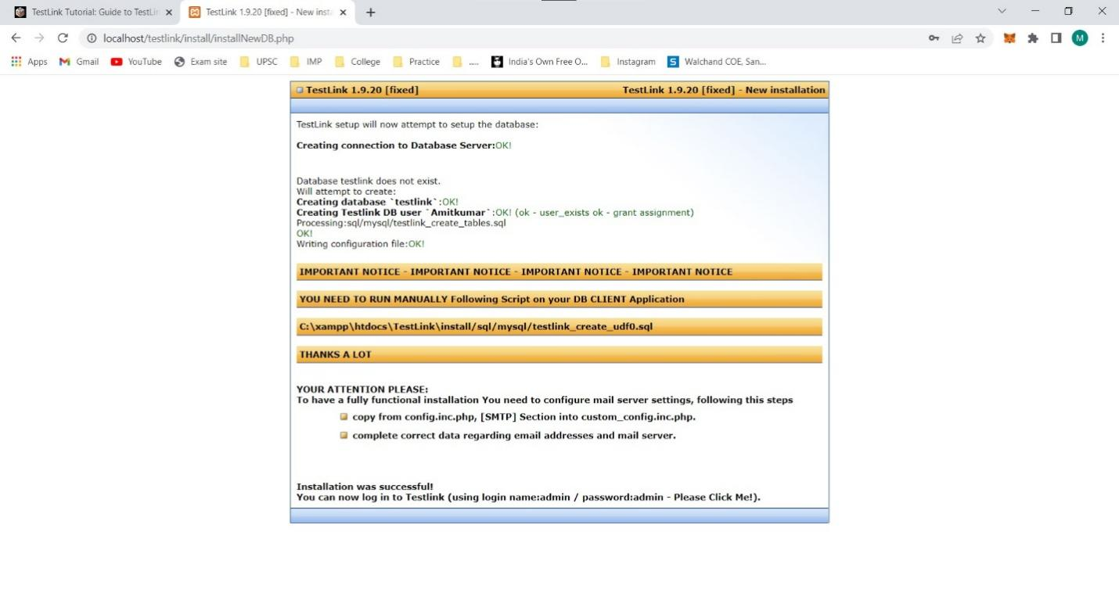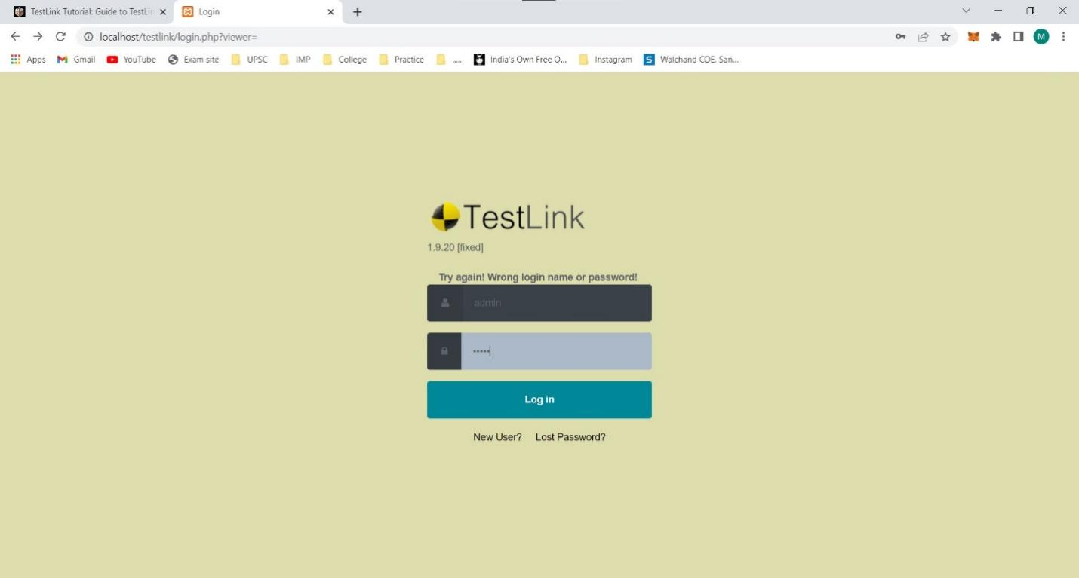

Q 3. Using TestLink tool create multiple test cases (at least 10) on any application/project that you have implemented.

Perform below tasks

a.Create New test project as SETProject

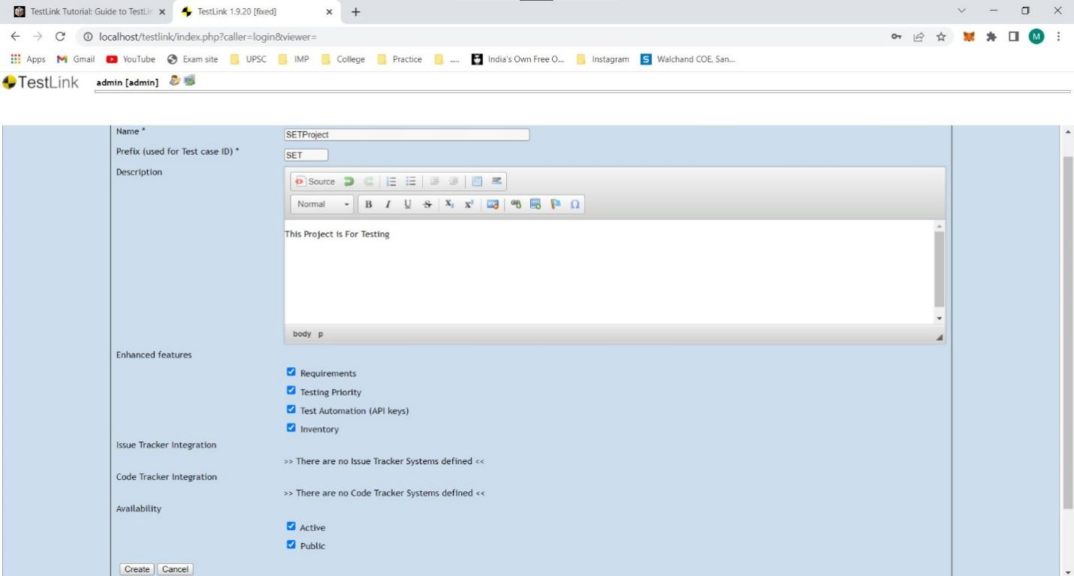

b.Create a test plan as SETProjectTestPlan

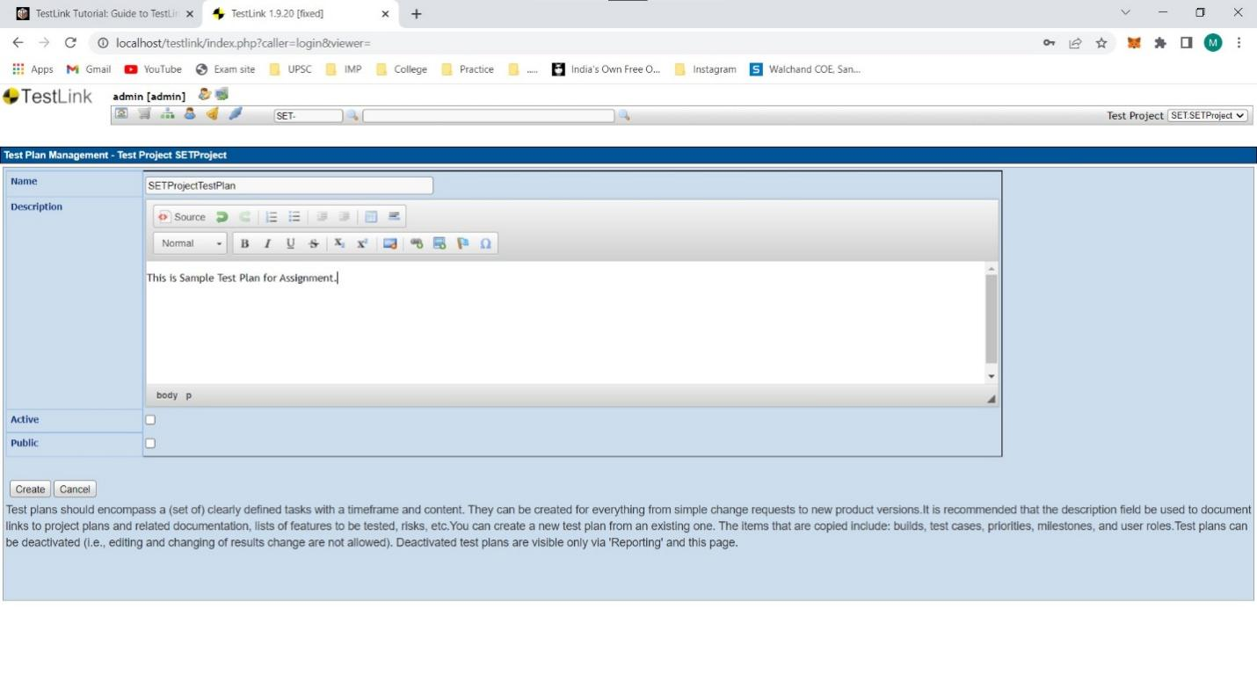

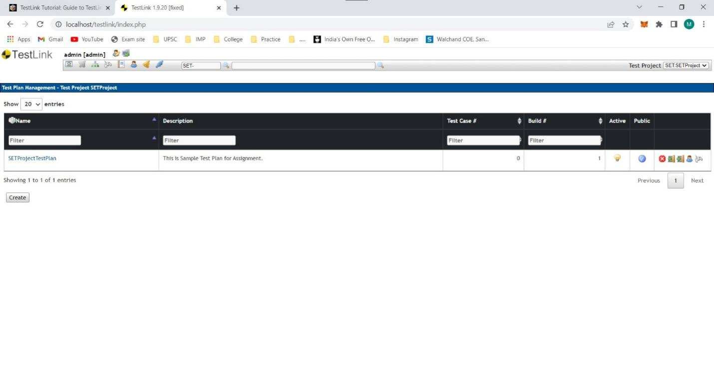

c.Create a build as SETProjectBuild

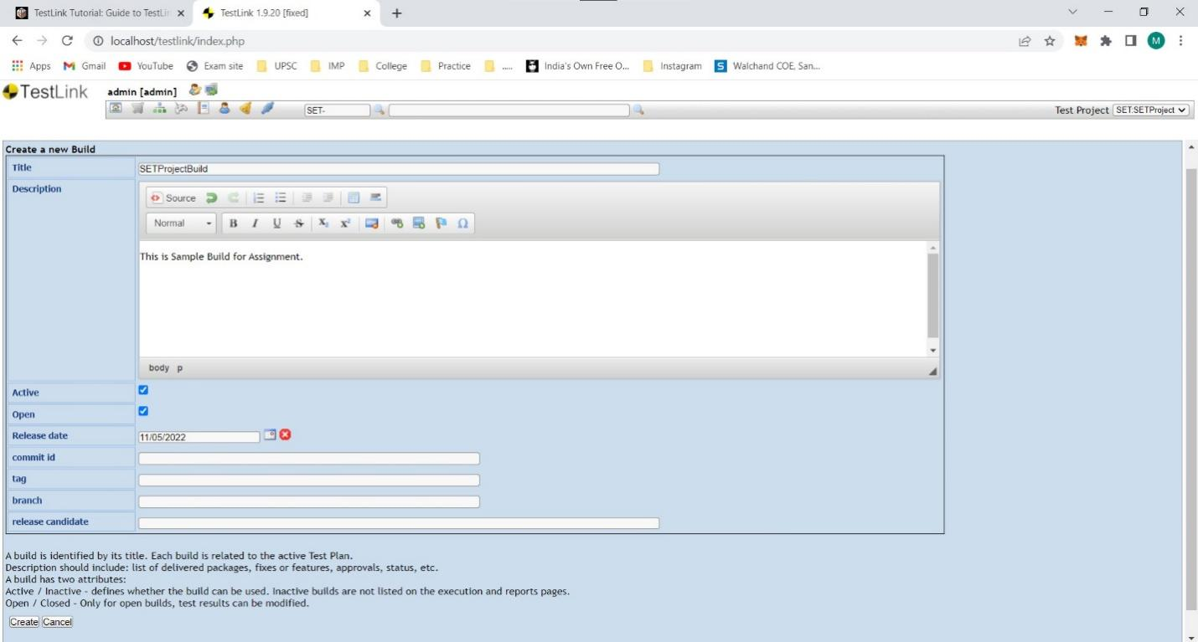

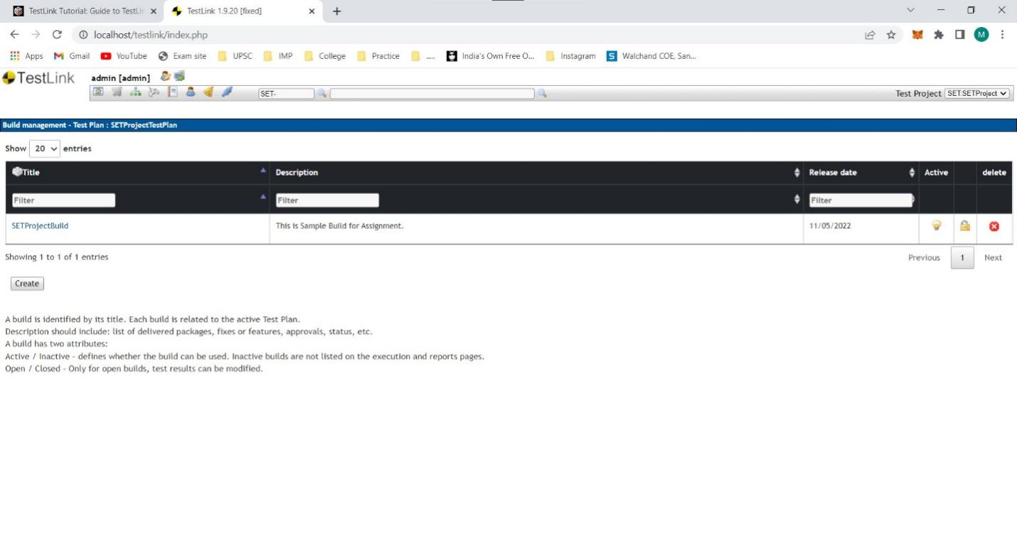

d.Create test suite as Test Suite 1 under SETProject

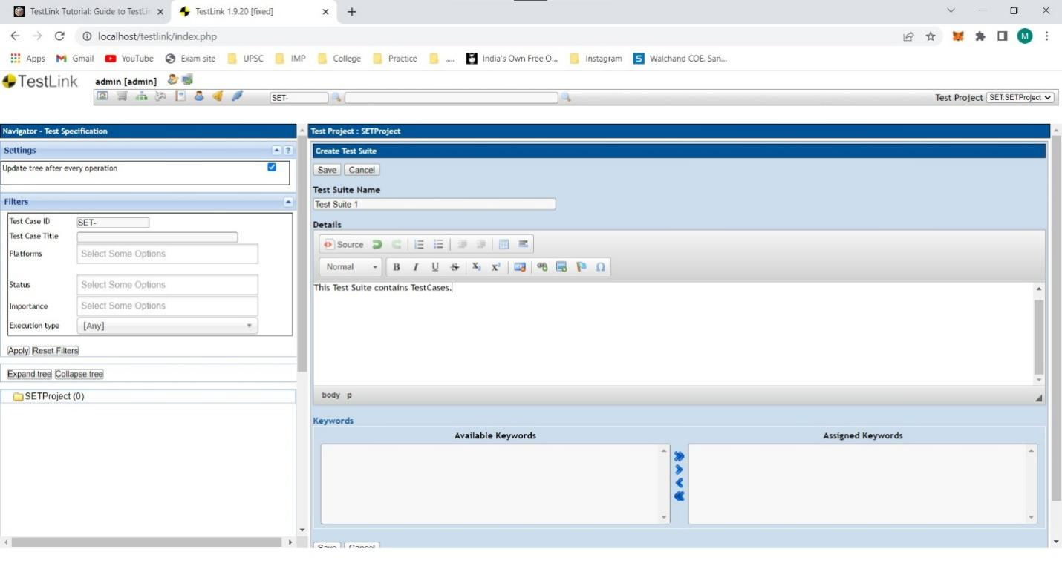

e.Create Test cases in TestLink Tool

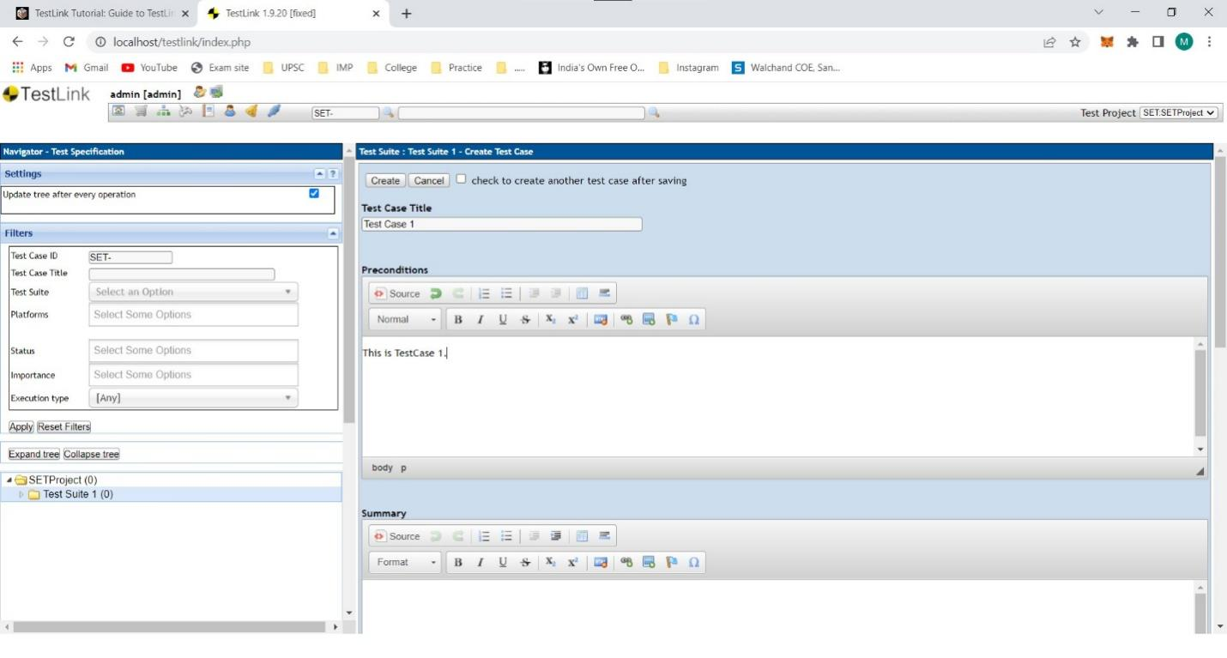

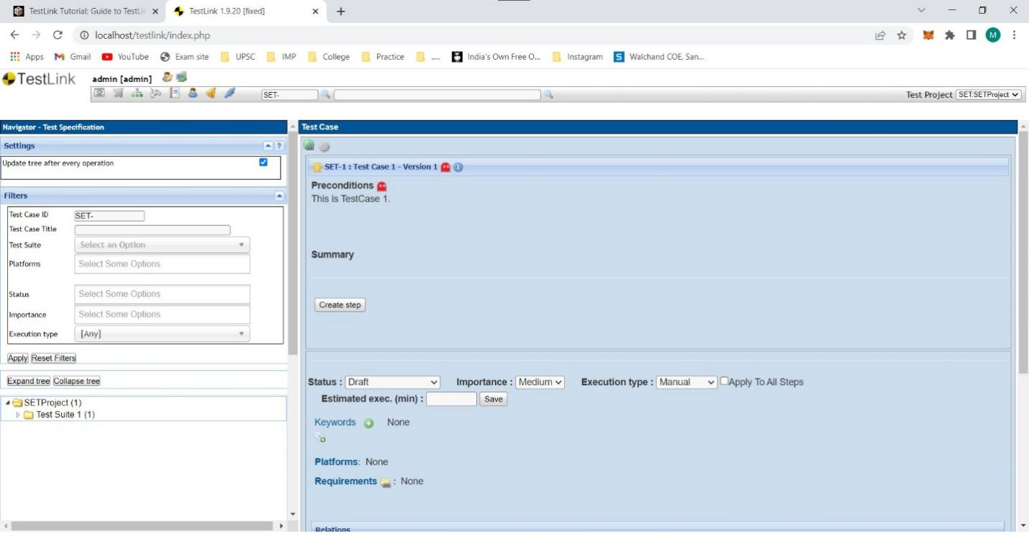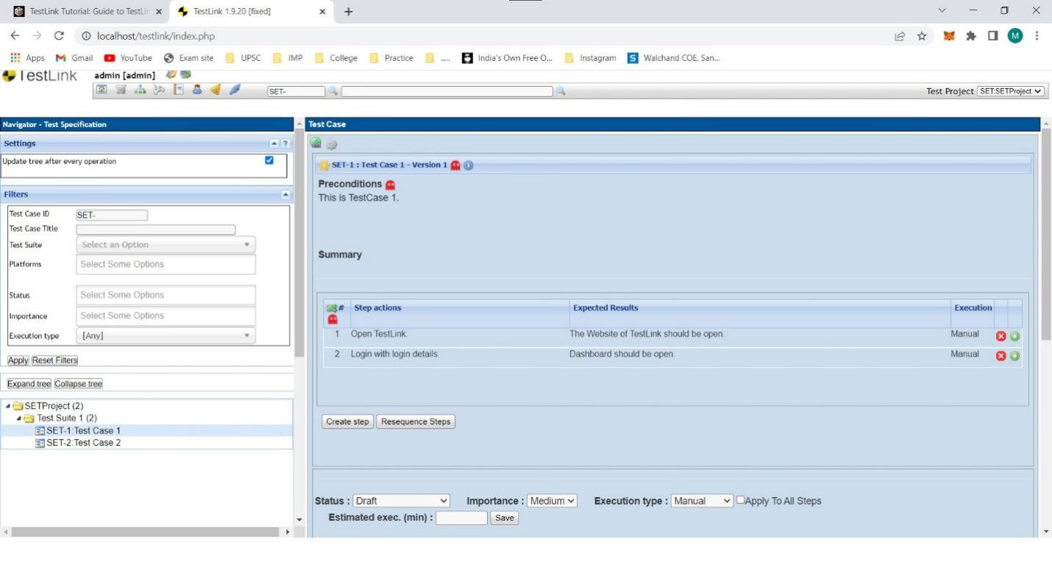

f.Assign created Test Cases to the test plan SETProjectTestPlan

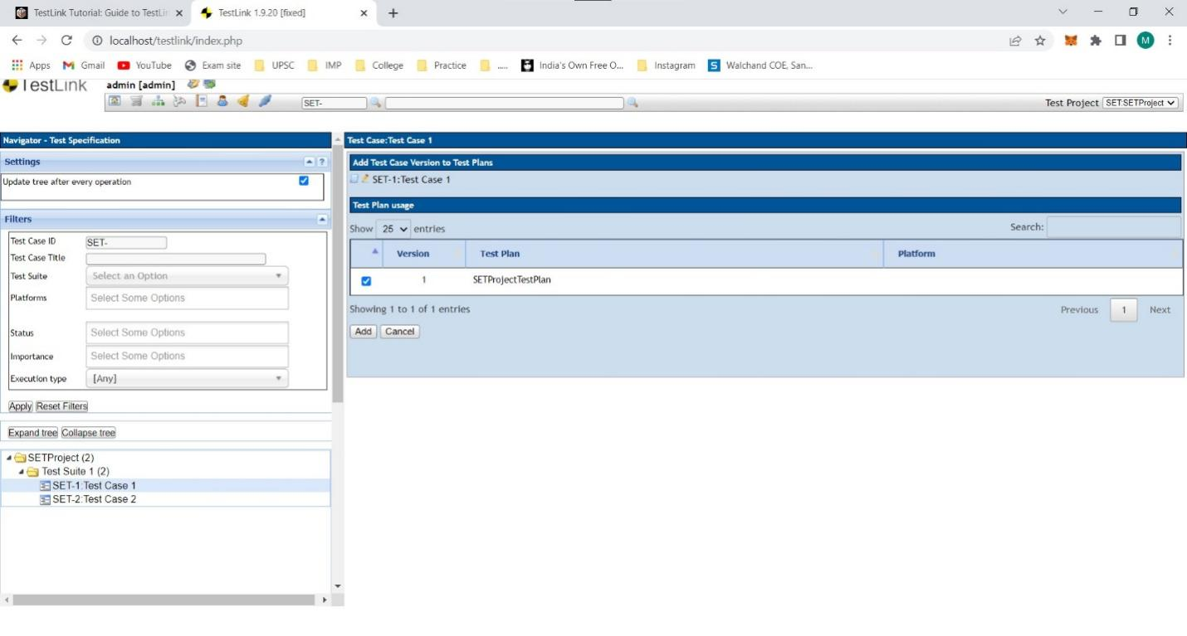

g.Create different roles as given below in the TestLink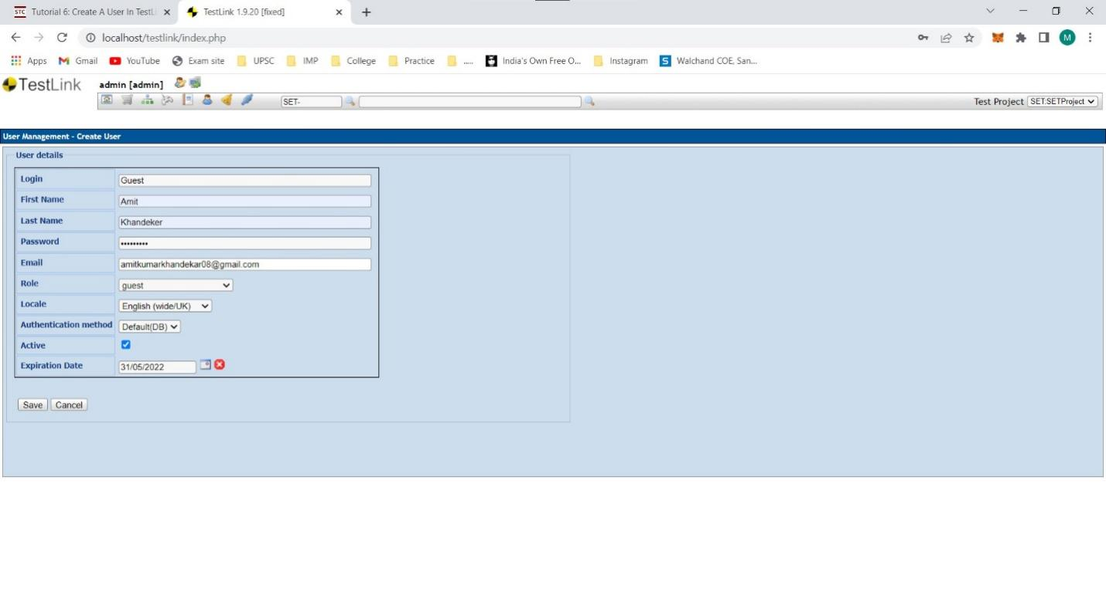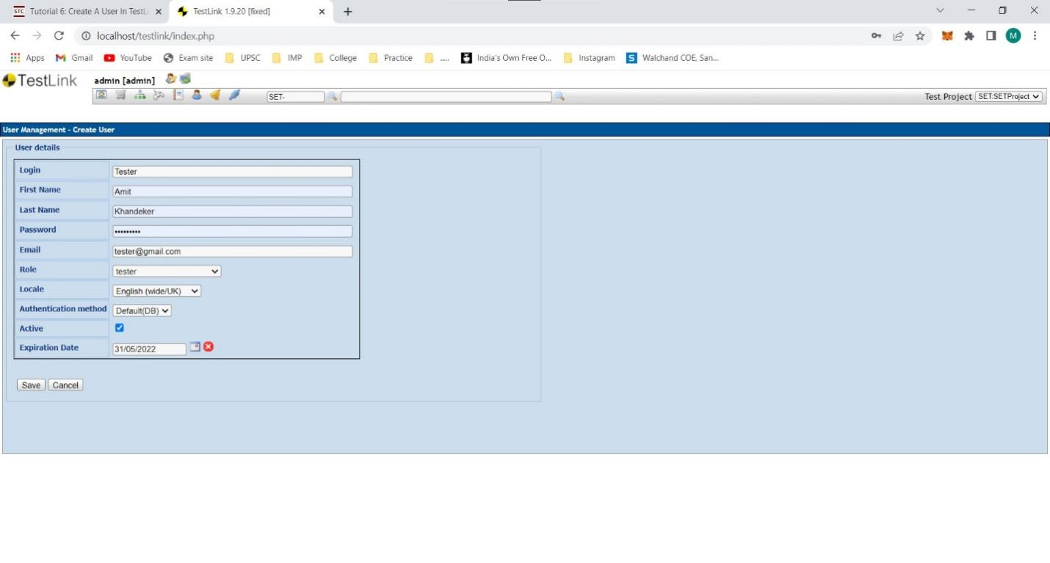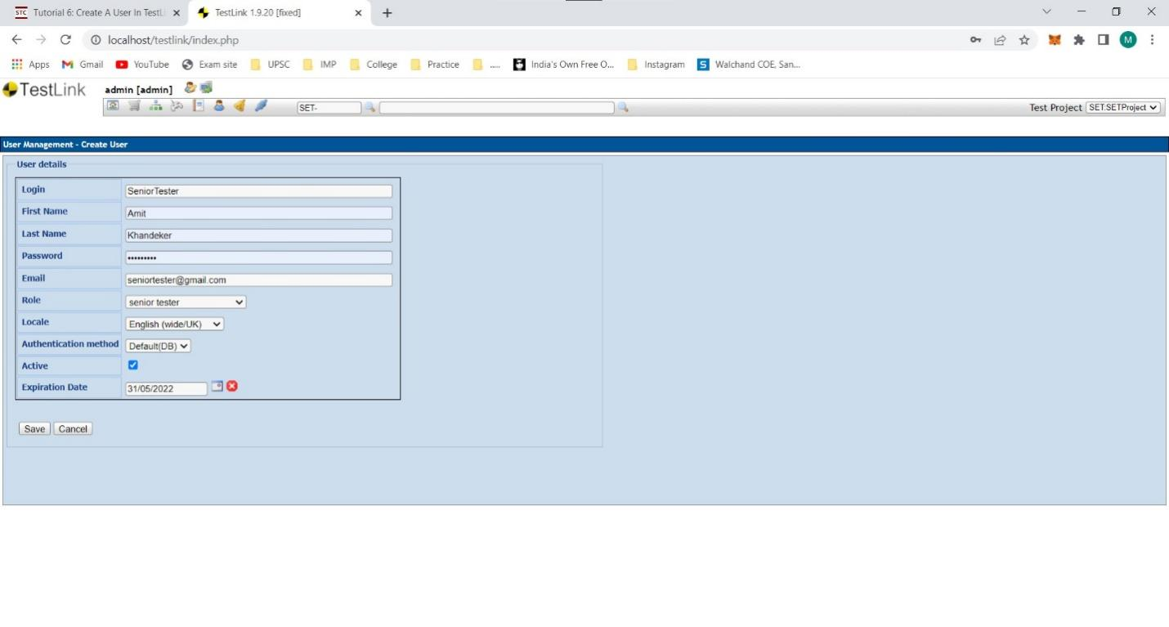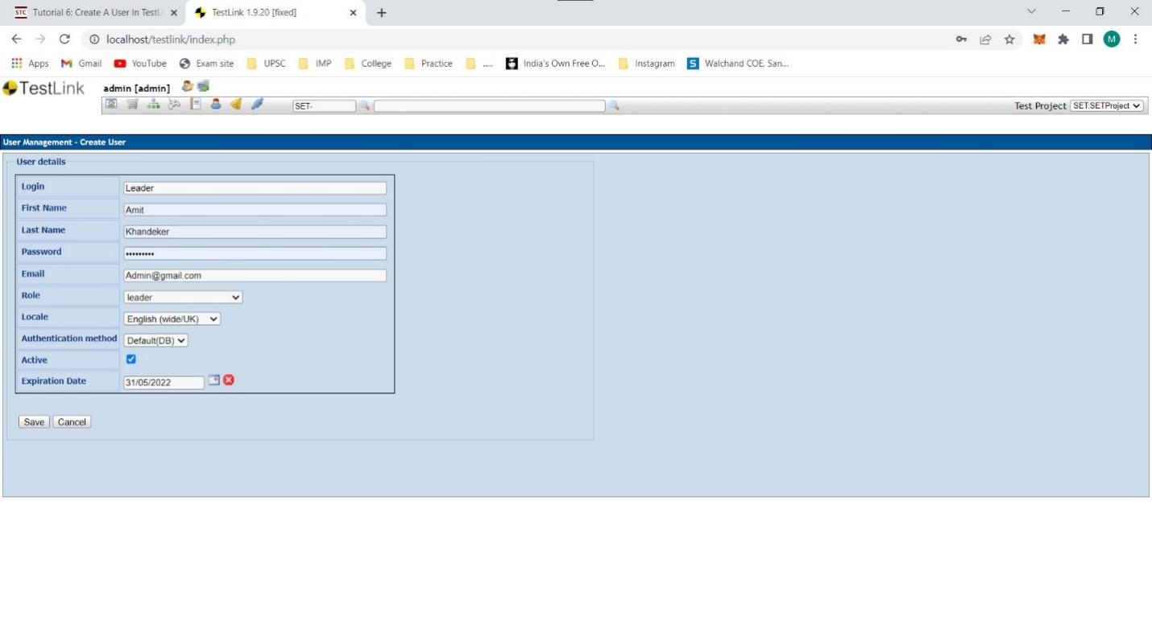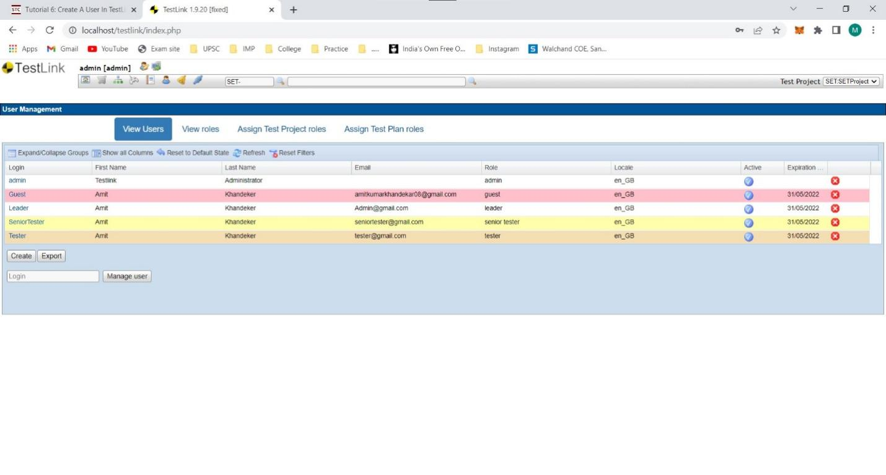

h.Write a requirements in TestLink

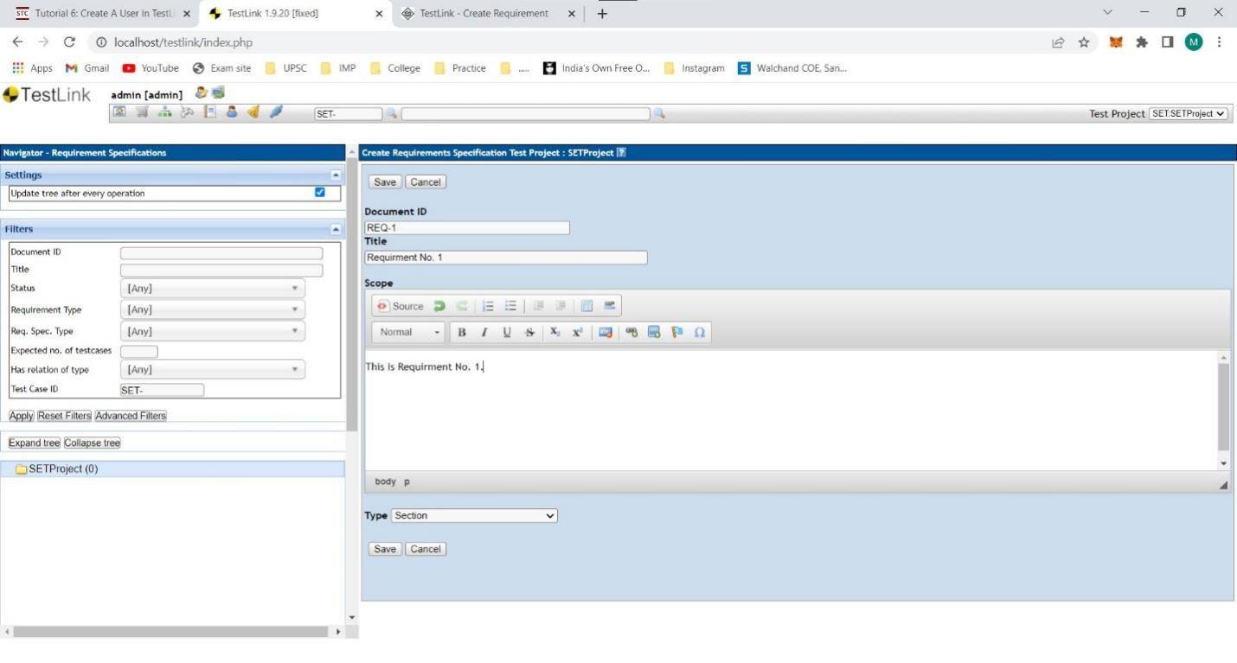

i.Execute test cases

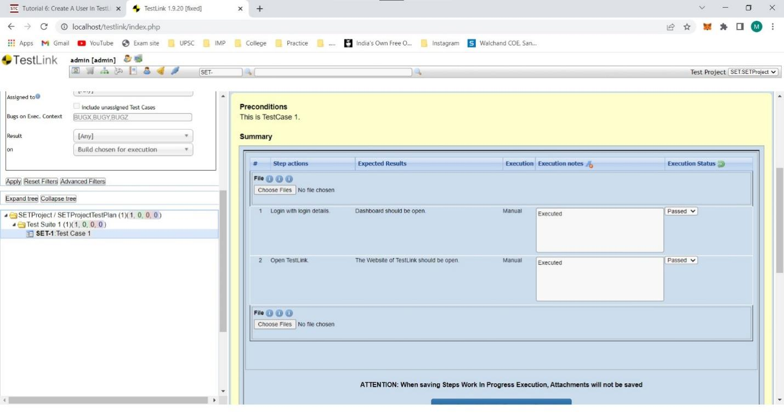

j.Generate a test report in excel format.

